Lab 13: Code Refactoring – Improving Legacy Code with AI
Suggestions
Lab Objectives:
• Identify code smells and inefficiencies in legacy Python
scripts.
• Use AI-assisted coding tools to refactor for readability,
maintainability, and performance.
• Apply modern Python best practices while ensuring output
correctness.
Task Description #1 (Refactoring – Removing Code
Duplication)
• Task: Use AI to refactor a given Python script that contains
multiple repeated code blocks.
• Instructions:
o Prompt AI to identify duplicate logic and replace it
with functions or classes.
o Ensure the refactored code maintains the same output.
o Add docstrings to all functions.
• Sample Legacy Code:
# Legacy script with repeated logic
print("Area of Rectangle:", 5 * 10)
print("Perimeter of Rectangle:", 2 * (5 + 10))
print("Area of Rectangle:", 7 * 12)
print("Perimeter of Rectangle:", 2 * (7 + 12))
print("Area of Rectangle:", 10 * 15)
print("Perimeter of Rectangle:", 2 * (10 + 15))
• Expected Output:
o Refactored code with a reusable function and no
duplication.
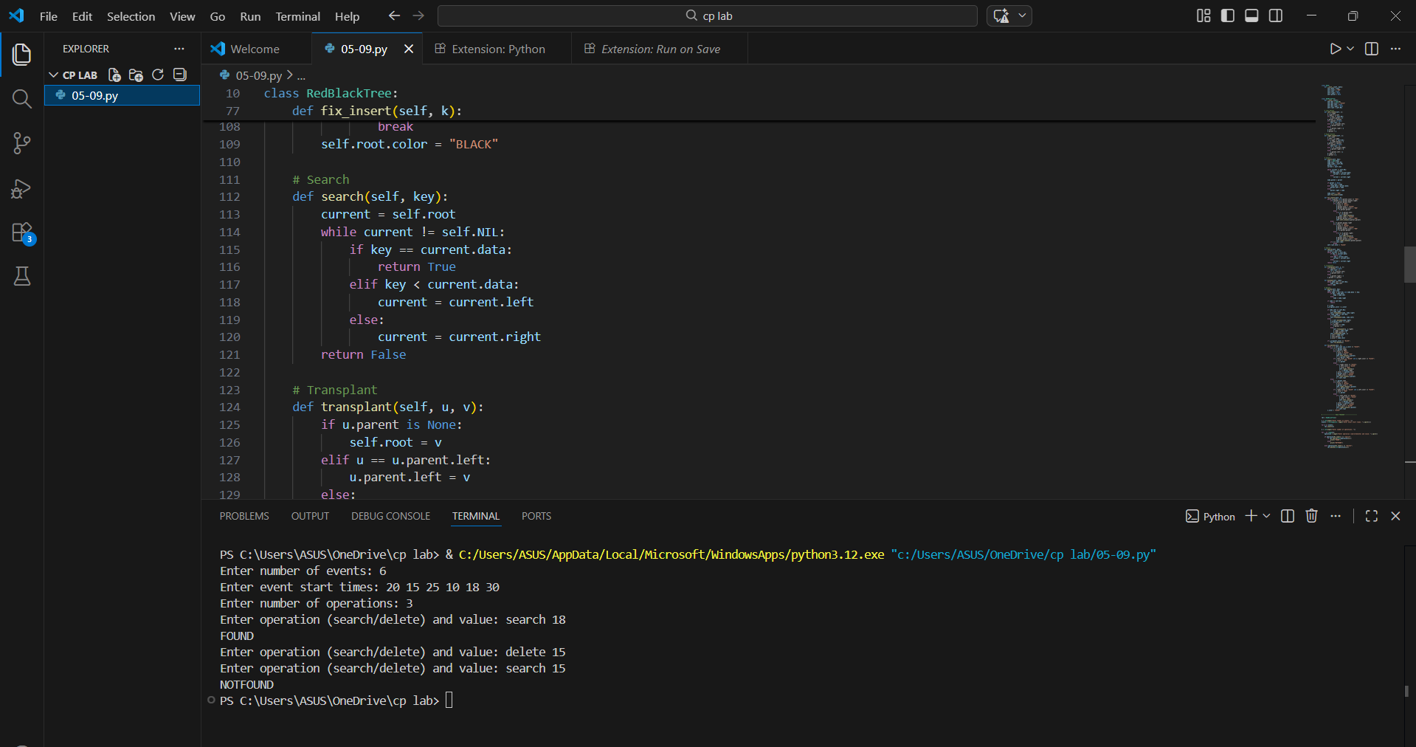
Task Description #2 (Refactoring – Optimizing Loops and
Conditionals)
• Task: Use AI to analyze a Python script with nested loops
and complex conditionals.
• Instructions:
o Ask AI to suggest algorithmic improvements (e.g.,
replace nested loops with set lookups or
comprehensions).
o Implement changes while keeping logic intact.
o Compare execution time before and after refactoring.
• Sample Legacy Code:
# Legacy inefficient code
names = ["Alice", "Bob", "Charlie", "David"]
search_names = ["Charlie", "Eve", "Bob"]
for s in search_names:
found = False
for n in names:
if s == n:
found = True
if found:
print(f"{s} is in the list")
else:
print(f"{s} is not in the list")
• Expected Output:
o Optimized code using set lookups with performance
comparison table.
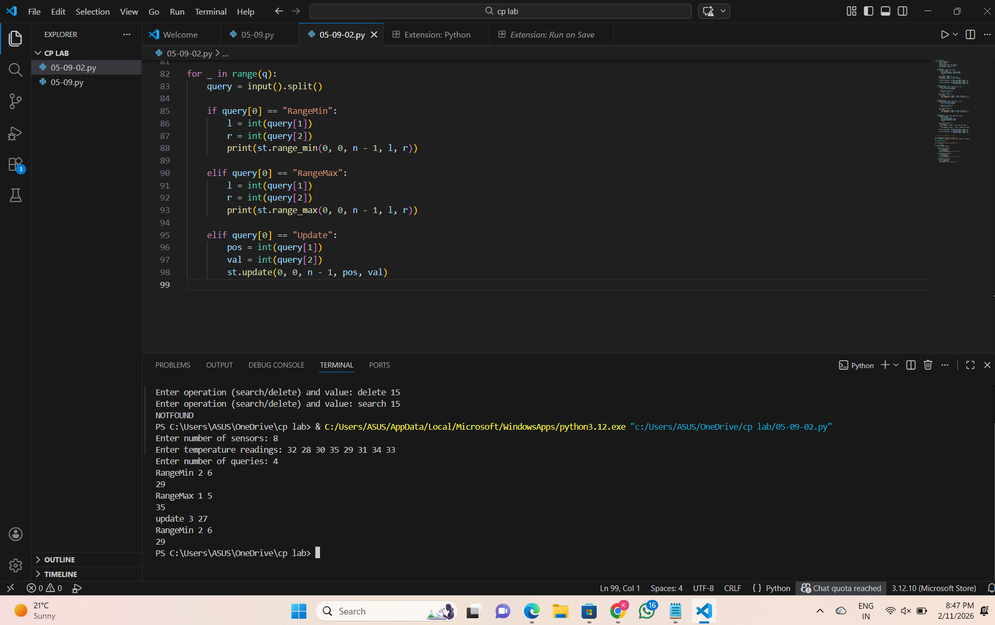
Task Description #3 (Refactoring – Extracting Reusable
Functions)
• Task: Use AI to refactor a legacy script where multiple
calculations are embedded directly inside the main code
block.
• Instructions:
o Identify repeated or related logic and extract it into
reusable functions.
o Ensure the refactored code is modular, easy to read,
and documented with docstrings.
• Sample Legacy Code:
# Legacy script with inline repeated logic
price = 250
tax = price * 0.18
total = price + tax
print("Total Price:", total)
price = 500
tax = price * 0.18
total = price + tax
print("Total Price:", total)
• Expected Output:
o Code with a function calculate_total(price) that can be
reused for multiple price inputs.
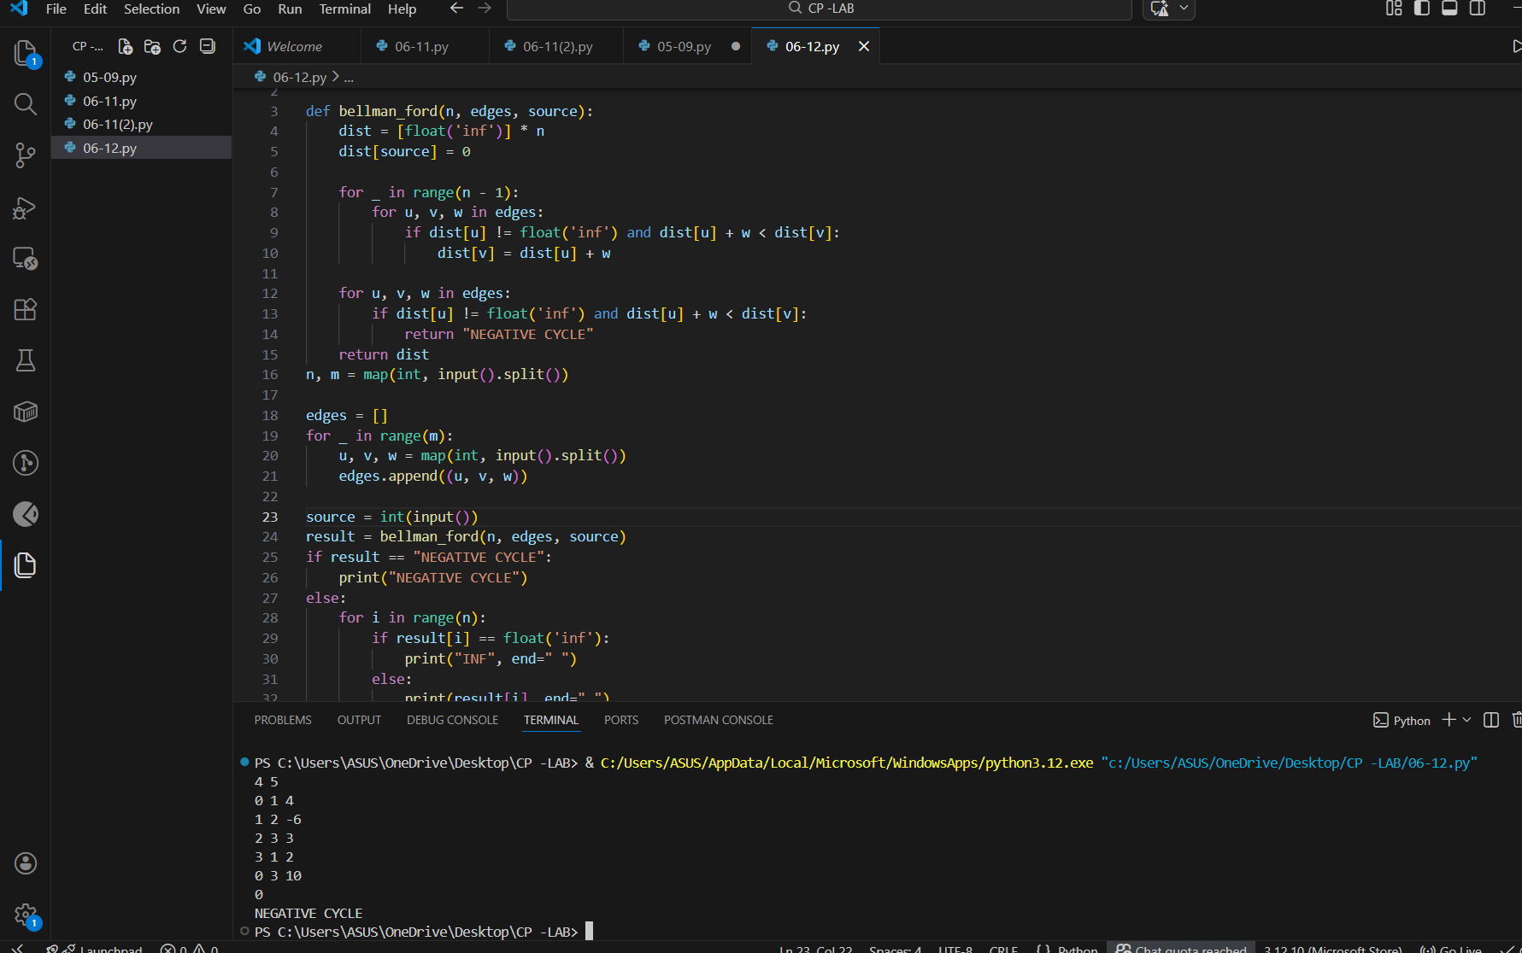
Task Description #4 (Refactoring – Replacing Hardcoded
Values with Constants)
• Task: Use AI to identify and replace all hardcoded “magic
numbers” in the code with named constants.
• Instructions:
o Create constants at the top of the file.
o Replace all hardcoded occurrences in calculations
with these constants.
o Ensure the code remains functional and is easier to
maintain.
• Sample Legacy Code:
# Legacy script with hardcoded values
print("Area of Circle:", 3.14159 * (7 ** 2))
print("Circumference of Circle:", 2 * 3.14159 * 7)
• Expected Output:
o Code with constants like PI = 3.14159 and RADIUS
= 7 used in calculations.

Task Description #5 (Refactoring – Improving Variable
Naming and Readability)
• Task: Use AI to improve readability by renaming unclear
variables and adding inline comments.
• Instructions:
o Replace vague names with meaningful ones.
o Add comments where logic is not obvious.
o Keep functionality exactly the same.
• Sample Legacy Code:
# Legacy script with poor variable names
a = 10
b = 20
c = a * b / 2
print(c)
• Expected Output:
o Code with descriptive variable names like base,
height, area_of_triangle, plus explanatory comments.
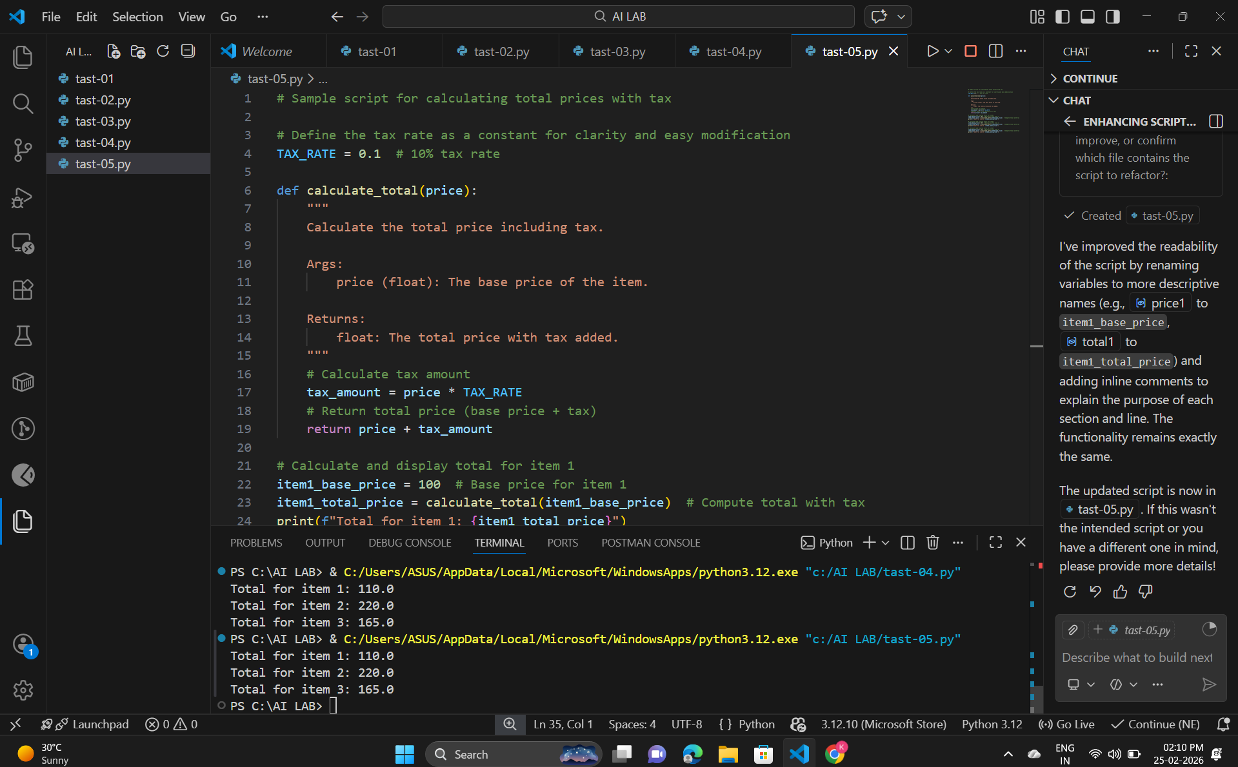
Task Description #6 (Refactoring – Removing Redundant Conditional
Logic)
• Task: Use AI to refactor a Python script that contains repeated if–else
logic for grading students.
• Instructions:
o Ask AI to identify redundant conditional checks.
o Replace them with a reusable function.
o Ensure grading logic remains unchanged.
• Code:
marks = 85
if marks >= 90:
print("Grade A")
elif marks >= 75:
print("Grade B")
else:
print("Grade C")
marks = 72
if marks >= 90:
print("Grade A")
elif marks >= 75:
print("Grade B")
else:
print("Grade C")
• Expected Output:
o A reusable function like calculate_grade(marks) with clean logic and
docstring.
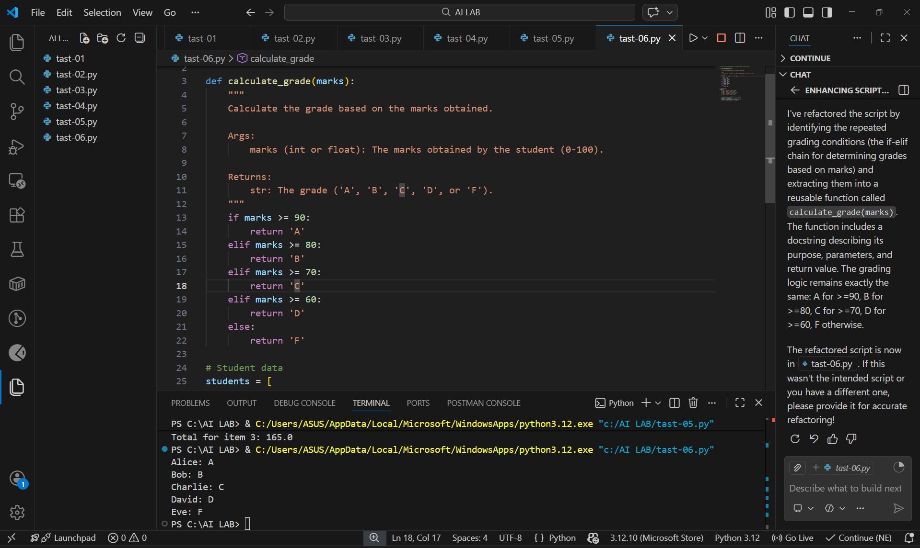
Task Description #7 (Refactoring – Converting Procedural Code to
Functions)
• Task: Use AI to refactor procedural input–processing logic into
functions.
• Instructions:
o Identify input, processing, and output sections.
o Convert each into a separate function.
o Improve code readability without changing behavior.
• Sample Legacy Code:
num = int(input("Enter number: "))
square = num * num
print("Square:", square)
• Expected Output:
o Modular code using functions like get_input(), calculate_square(),
and display_result().
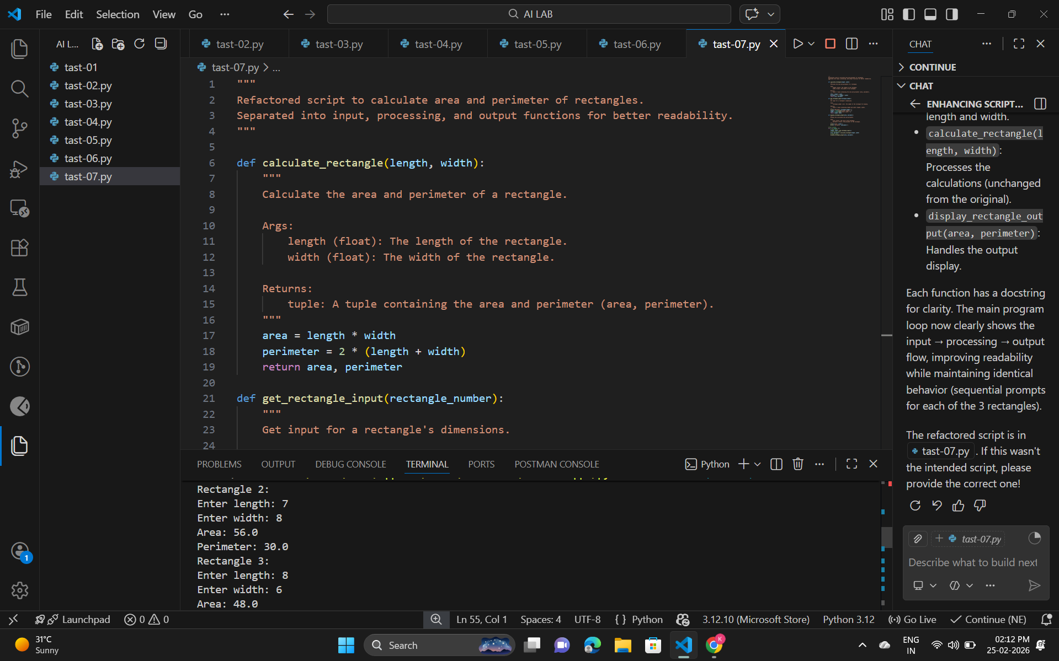
Task Description #8 (Refactoring – Optimizing List Processing)
• Task: Use AI to refactor inefficient list processing logic.
• Instructions:
o Ask AI to replace manual loops with list comprehensions or built-in
functions.
o Ensure output remains identical.
• Sample Legacy Code:
nums = [1, 2, 3, 4, 5]
squares = []
for n in nums:
squares.append(n * n)
print(squares)
• Expected Output:
o Optimized version using list comprehension with improved
readability
